Replace all the red text in this document before submission.
Solent University

School: Department of Science and Engineering
Course: Cyber Security
Module: Introduction to Databases (COM430)
Assessment: AE2 Portfolio

Student: 103048653
Date: 30/04/2026

Contents page
Part 1 – Database Design, Implementation and Integrity
Question a 3
Question b 4
Question c 4
Question d 6
Part 2 – Programming for Databases 12
Bibliography 16

PART 1 - Database Design, Implementation and Integrity
- QUESTION:

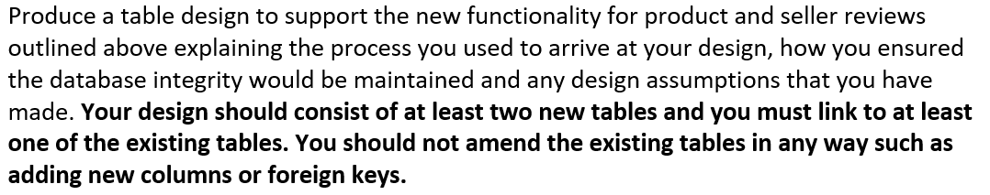

My design consists of the new seller_reviews and product_reviews tables. In the conceptual stage of the design, I broke the design down to the basics of just the two tables. I then referred to the brief to think about the columns which would exist within each table. I then broke it down that both tables requires a star rating, comment reviews from shoppers and the date and time that they are submitted. I knew that each table would also need a column to identify the review number, so I included a product and seller review id. Then in the logical stage, I began to view how they would link together, prompting me to add a product id to the product reviews and a seller id to the seller reviews. I then assigned primary keys to both, making the product review id and seller review id the primary key of their respective tables. I subsequently made the seller and product id’s the foreign keyts toallow them to link to the seller and product tables. I then realised that due the reviews being by the shoppers, the tables had to link to the shoppers table as well, so I added the shopper id as a foreign key for both so they could link to the shoppers table. I then moved on to the final logical design and created the ERD to show how all the new tables link to the current tables. I then added datatypes to all the columns in the physical design.

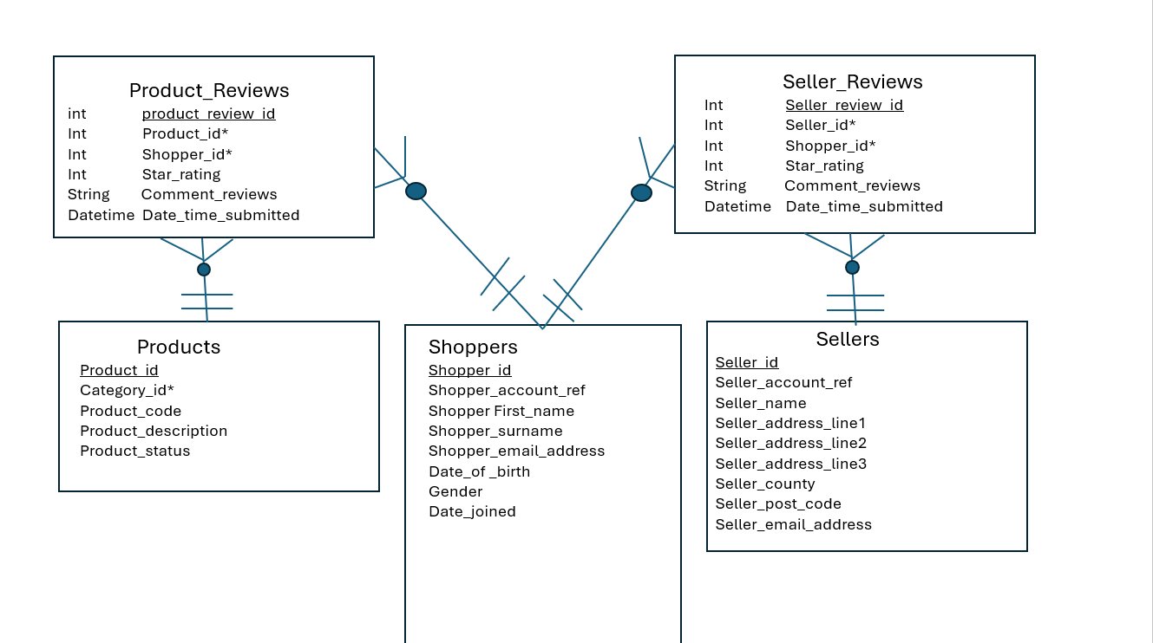
- QUESTION:

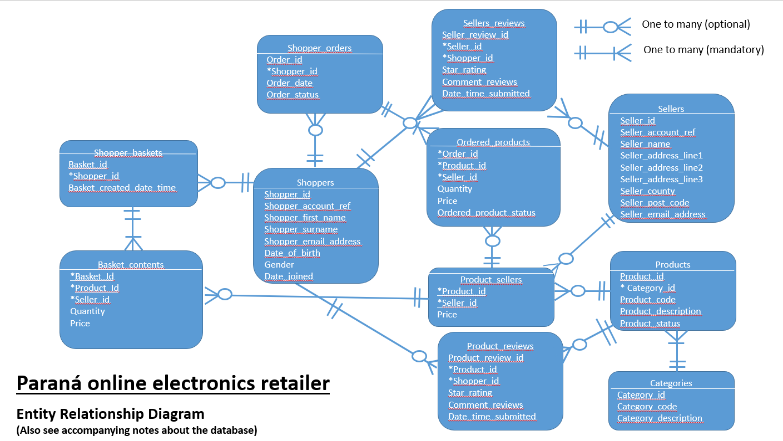
- QUESTION:

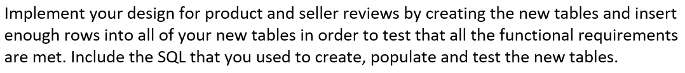
Creating tables:
CREATE TABLE product_reviews(
product_review_id INTEGER PRIMARY KEY AUTOINCREMENT,
product_id INTEGER NOT NULL,
shopper_id INTEGER NOT NULL,
star_rating INTEGER NOT NULL CHECK (star_rating BETWEEN 1 AND 5),
comment_reviews TEXT,
date_time_submitted DATETIME NOT NULL,
FOREIGN KEY (product_id) REFERENCES Products(product_id),
FOREIGN KEY (shopper_id) REFERENCES Shoppers(shopper_id)
);

CREATE TABLE seller_reviews(
seller_review_id INTEGER PRIMARY KEY AUTOINCREMENT,
seller_id INTEGER NOT NULL,
shopper_id INTEGER NOT NULL,
star_rating INTEGER NOT NULL CHECK (star_rating BETWEEN 1 AND 5),
comment_reviews TEXT,
date_time_submitted DATETIME NOT NULL,
FOREIGN KEY (seller_id) REFERENCES Sellers(seller_id),
FOREIGN KEY (shopper_id) REFERENCES Shoppers(shopper_id)

Populating tables:
INSERT INTO product_reviews
(product_id, shopper_id, star_rating, comment_reviews, date_time_submitted)
VALUES
(3000000, 10000, 5, 'Brilliant product, would 100% reccommend', '2026-03-21 10:30:00'),
(3006033, 10008, 4, 'Decent product but too expensive', '2026-05-19 15:20:00'),
(3007905, 10010, 3, 'Not great but does the job', '2026-04-15 12:25:00'),
(3007903, 10004, 2, 'Very disappointed, would not reccommend', '2026-04-02 13:27:00'),
(3005955, 10020, 1, 'Terrible product, never buying again', '2026-03-03 17:38:00')

INSERT INTO seller_reviews
(seller_id, shopper_id, star_rating, comment_reviews, date_time_submitted)
VALUES
(200007, 10012, 5, 'Brilliant service and a great seller', '2026-02-03 12:30:00'),
(200009, 10011, 4, 'Very fast response time and delivery', '2026-01-05 11:22:00'),
(200011, 10017, 3, 'Okay experience, not the greatest ive had', '2026-04-22 13:28:00'),
(200001, 10023, 2, 'Seller was very rude and took a while to deliver', '2026-03-19 10:14:00'),
(200003, 10013, 1, 'Appauling service, will be reporting', '2026-02-12 16:33:00')

Testing:
Multiple Reviews per product:

INSERT INTO Product_reviews
(product_id, shopper_id, star_rating, comment_reviews, date_time_submitted)
VALUES
(3000000, 10020, 5, 'Really happy with this product, 5/5 stars', '2026-04-15 14:22:00');

SELECT product_id, COUNT(*) AS review_count
FROM product_reviews
GROUP BY product_id

Multiple reviews per seller:
INSERT INTO seller_reviews
(seller_id, shopper_id, star_rating, comment_reviews, date_time_submitted)
VALUES
(200007, 10018, 3, 'Experience with seller was average', '2026-04-10 11:29:00');

SELECT seller_id, COUNT(*) AS review_count
FROM Seller_reviews
GROUP BY seller_id;

Multiple reviews by one shopper:
SELECT shopper_id, COUNT(*) AS total_reviews
FROM (
SELECT shopper_id FROM product_reviews
UNION ALL
SELECT shopper_id FROM seller_reviews
)
GROUP BY shopper_id;

- QUESTION:



Primary key test constraint:
Result fails in the test to show that primary keys must be unique to prevent duplicate records

INSERT INTO Product_reviews
(product_review_id, product_id, shopper_id, star_rating, comment_reviews, date_time_submitted)
VALUES (6, 3007689, 10011, 5, 'Duplicate ID test', '2026-03-15 15:20:00');
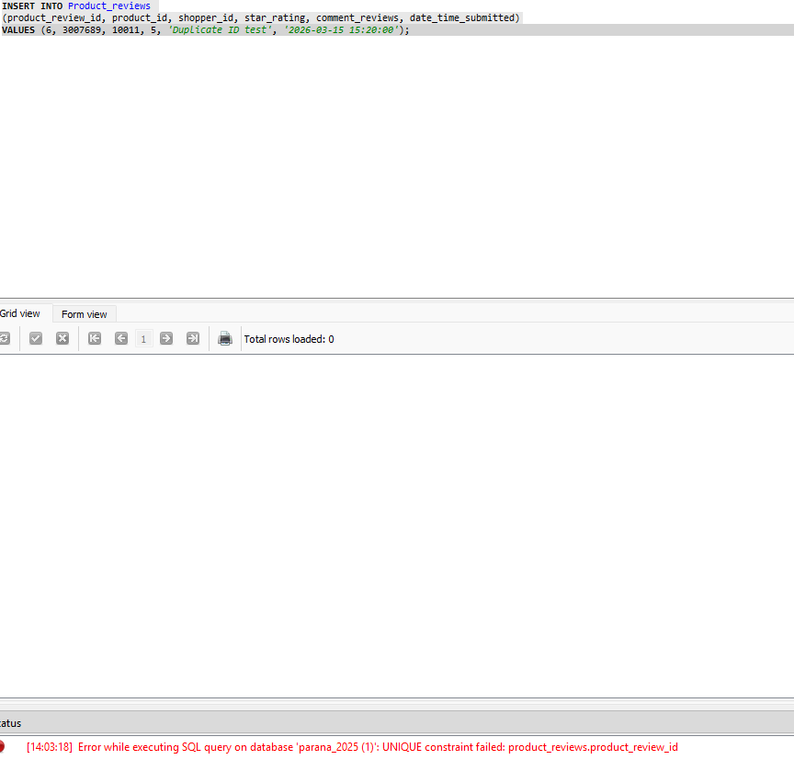

Foreign key constraint:
Result fails to show that foreign keys can only produce results for existing shoppers, products and sellers

INSERT INTO Product_reviews
(product_id, shopper_id, star_rating, comment_reviews, date_time_submitted)
VALUES (999, 10011, 4, 'Invalid product test', '2026-01-09 12:00:00');

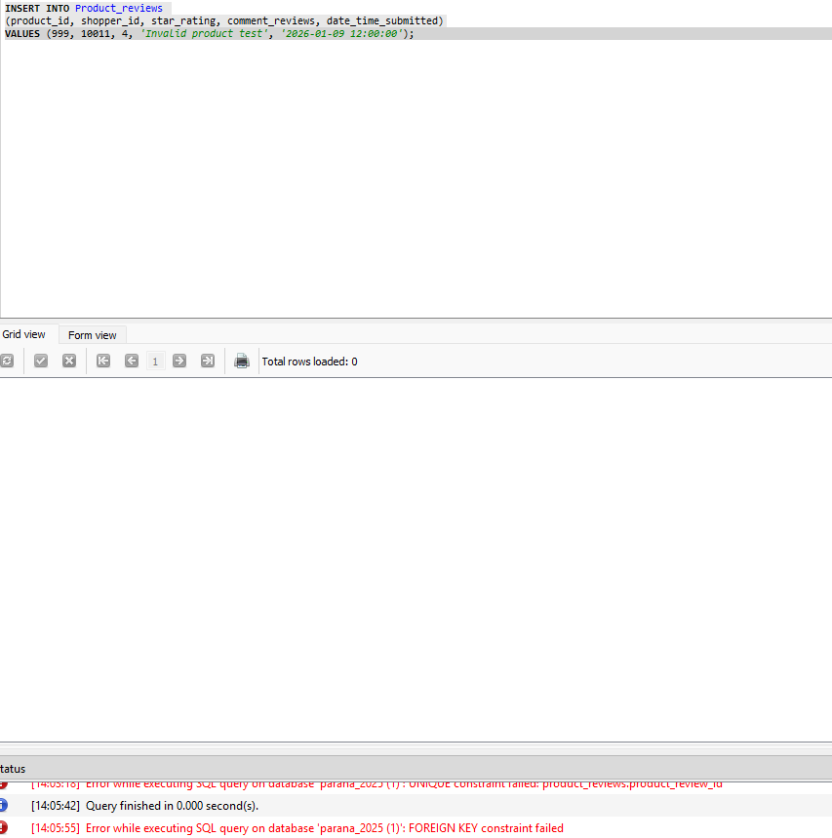

NOT NULL constraint:
Result fails to show that the field needs to always be provided and not be null

INSERT INTO Seller_reviews
(seller_id, shopper_id, star_rating, comment_reviews,date_time_submitted)
VALUES
(200000, 10006, 5, 'Missing date test', NULL);

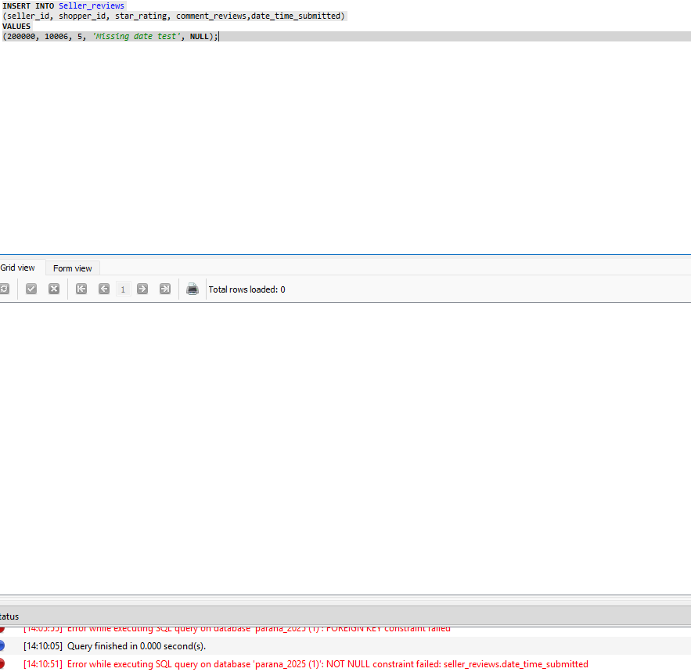

Check constraint:
Result fails to show that you cannot exceed the maximum value of rating and must be between 1 and 5

INSERT INTO product_reviews
(product_id, shopper_id, star_rating, comment_reviews, date_time_submitted)
VALUES
(3007869, 10008, 6, 'Exceeding rating range test', '2026-01-10 12:11:00')

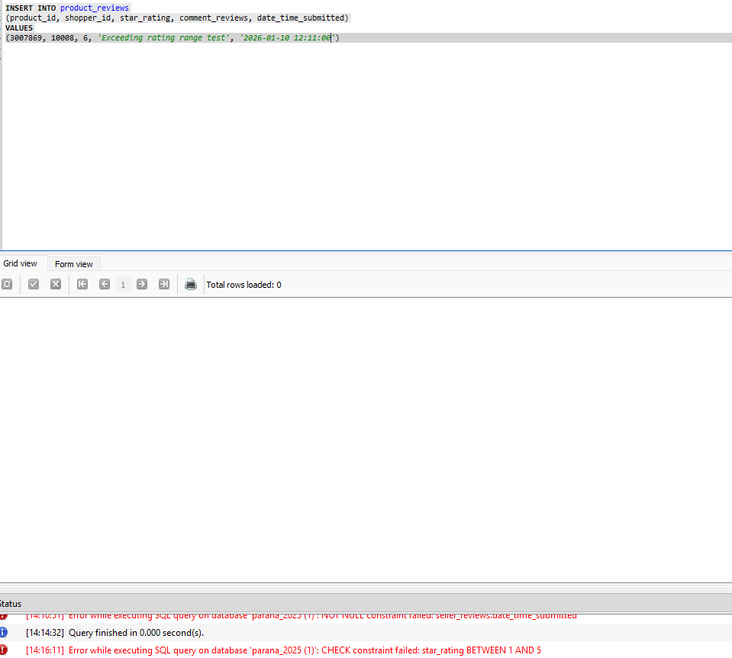

Unique constraint:
Result fails, similar to primary key constraint, to show that the seller_review_id cannot be a duplicate and must be unique

INSERT INTO seller_reviews
(seller_review_id, seller_id, shopper_id, star_rating, comment_reviews, date_time_submitted)
VALUES
(1, 200004, 10019, 4, 'duplicate seller review id test', '2026-04-22 14:37:00')

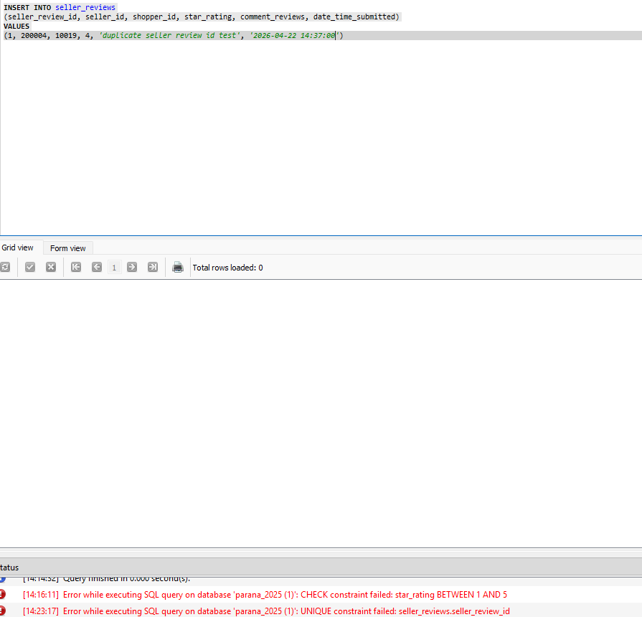

PART 2 – Programming for Databases
import sqlite3
db_file = "C:/Users/Downloads/parana_2025 (1).db"
db = sqlite3.connect(db_file)
# Get shopper details
def get_shopper(shopper_id):
with sqlite3.connect(db_file) as conn:
result = conn.execute("""
SELECT shopper_first_name, shopper_surname
FROM shoppers
WHERE shopper_id = ?
""", (shopper_id,)).fetchone()
return result
# View Shoppers orders
def view_orders(shopper_id):
with sqlite3.connect(db_file) as conn:
results = conn.execute("""
SELECT
so.order_id,
so.order_date,
p.product_description,
s.seller_name,
op.price,
op.quantity,
op.ordered_product_status
FROM shopper_orders so
JOIN ordered_products op ON so.order_id = op.order_id
JOIN product_sellers ps ON op.product_id = ps.product_id
AND op.seller_id = ps.seller_id
JOIN products p ON ps.product_id = p.product_id
JOIN sellers s ON ps.seller_id = s.seller_id
WHERE so.shopper_id = ?
ORDER BY so.order_date DESC
""", (shopper_id,)).fetchall()
# If no orders are found
if not results:
print("\nNo orders placed by this customer")
return
print("\n Customer Order History ")
current_order = None
for row in results:
order_id, order_date, desc, seller, price, qty, status = row
# print the order template
if order_id != current_order:
print(f"\nOrder ID: {order_id} | Date: {order_date}")
print("-" * 70)
print(f"{'Product':20} {'Seller':15} {'Price':8} {'Qty':5} {'Status'}")
current_order = order_id
print(f"{desc[:20]:20} {seller[:15]:15} {price:<8} {qty:<5} {status}")
# options menu
def show_menu(shopper_id):
while True:
print("\n Main Menu ")
print("1. Display Order History")
print("2. Add an item to your basket")
print("4. Change item quantity in basket")
print("5. Remove an item from your basket")
print("6. Checkout")
print("7. Exit")
choice = input("Enter your choice: ")
if choice == "1":
view_orders(shopper_id)
elif choice == "2":
print("Adding an item to your basket")
elif choice == "3":
print("Viewing basket")
elif choice == "4":
print("Changing quantity")
elif choice == "5":
print("Removing an item")
elif choice == "6":
print("Checking out")
elif choice == "7":
print("Goodbye")
break
else:
print("Invalid choice. Please try again.")
# The main program
def main():
print(" Welcome to the Electronics Shopping System ")
try:
shopper_id = int(input("Enter your Shopper ID: "))
except ValueError:
print("Error: Shopper ID must be a number.")
return
shopper = get_shopper(shopper_id)
if shopper:
print(f"\nWelcome, {shopper[0]} {shopper[1]}")
show_menu(shopper_id)
else:
print("\nError: Shopper ID not found. Exiting program.")
if __name__ == "__main__":
main()

The code meets the first requirement by displaying the order id, date, product description, sellers name, price, quantity and order status. From the testing shown, the most recent order is first in order of date. From the testing below, you can see that with a custokmer with no orders, the program does output, “No orders placed by this customer”. The program is in the specified order shown. There is an option to return to exit the program as needed by option 7.

Incorrect Shopper ID entered:

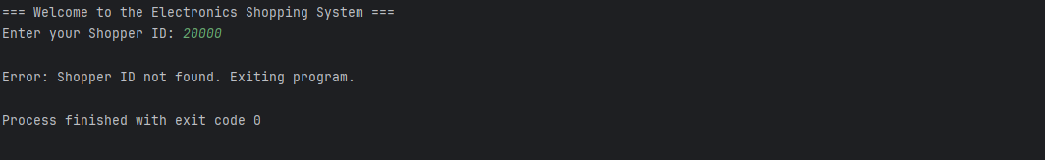
Most recent order is first:

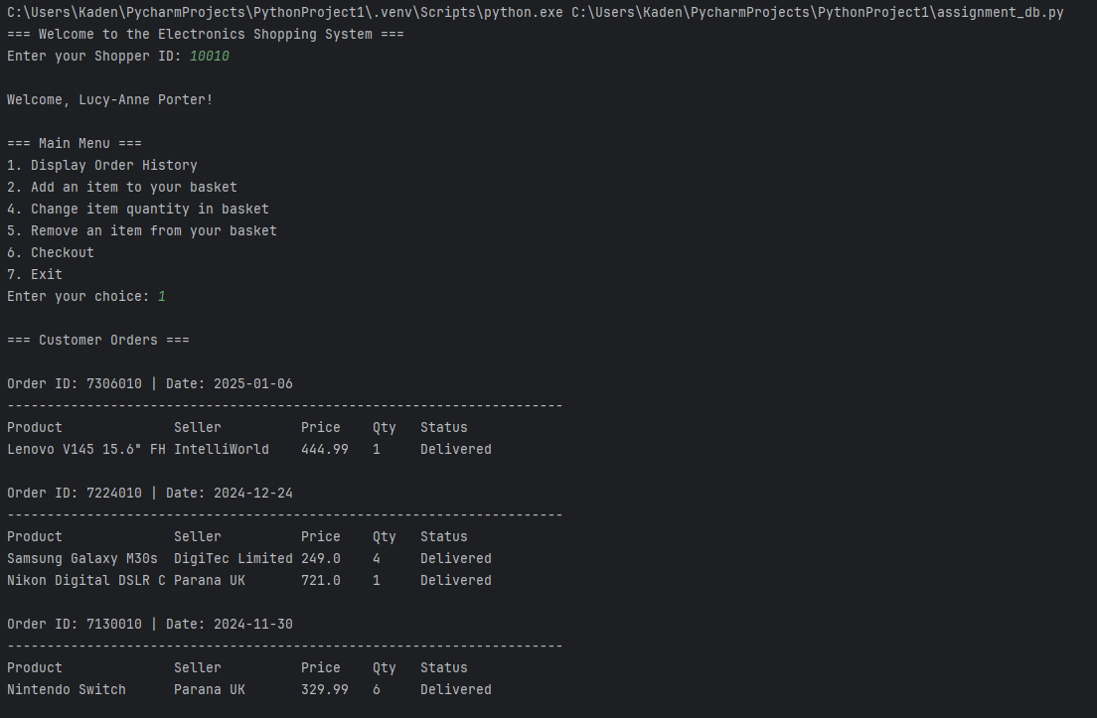
No orders placed by the customer:

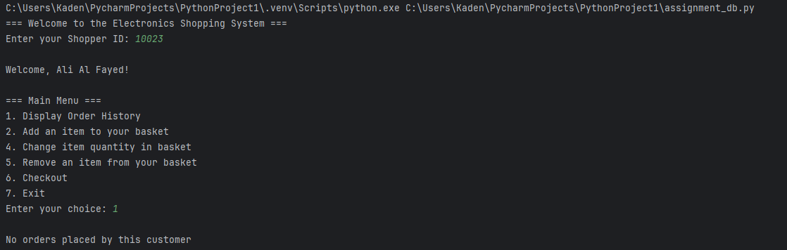

Invalid menu input:
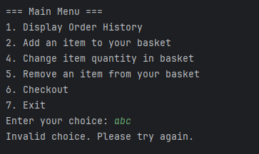

Bibliography

List any Internet sources of information that you used in order to help complete your assessment. You do not need to include references to any of the learning materials provided on SOL for this module, just other external sources.

For instance, if you consulted an article on the SQLite online documentation page on AUTOINCREMENT, you would list it here along with the date you accessed it as shown below:

SQLite (2017) SQLite Autoincrement. Available at https://www.sqlite.org/autoinc.html (Accessed 29th April 2023)

Geeksforgeeks (2022) SQL using Python. Link: https://www.geeksforgeeks.org/python/sql-using-python/ (Accessed April 6 2026 )
Freecodecamp (2020) How to create and manipulate sql databases with python. Link: https://www.freecodecamp.org/news/connect-python-with-sql/ (Accessed April 10 2026)
Rob Mulla (2023) SQL databases with pandas and python – a complete guide. Link:https://www.youtube.com/watch?v=DiQ5Hni6oRI (Accessed April 6 2026)

